Sim step 2 -- implementation summary
Implemented and run autonomously overnight, per your instructions. This covers the tissue_3d_generator.m averaging bug fix, the new 35x35x15um capillary/RBC tissue, and step_two.py. step_one.py and the two existing tissues (20x20x10, 50x50x10) were deliberately NOT touched -- see the last section.

1. The bug found in tissue_3d_generator.m
The z-downsampling loop that averages the fine (x_stp-spaced) tissue volume into M coarse aberration planes used a fixed tolerance (x_stp*0.75) to decide which fine layers belong to each coarse plane, instead of one that scales with the plane's own thickness. Since the fine grid is x_stp-spaced, that fixed tolerance could only ever catch 1-2 adjacent fine layers -- regardless of how many (smp_z = z_stp/x_stp, typically 50-75 in this project) were actually supposed to be averaged together. Every "plane" generated so far -- both existing tissues, and everything in step_one.py -- was therefore effectively a thin ~0.1-0.2um slice at one z-position, not the intended average over a full plane-thickness slab of tissue.
Fix (tissue_3d_generator.m, the z-downsampling loop):
ii0 = find(abs(z_grid1-z_grid1_sps(j)) <= h_z_stp + x_stp*0.1);
h_z_stp is the bin half-width (already defined earlier in the file as z_stp/2). Added a post-loop assertion (length(ii0)==smp_z for every bin) so this can't silently regress again. Verified directly in the generation log for the new tissue: both bins now catch exactly 75 fine layers each (matching smp_z=75), tiling the full depth with no gap or overlap -- previously it was 2.

2. What this changes about how the M=2 planes relate to the tissue
With the fix, plane A's averaging window is forward z in [0, Z_tissue/2] (entrance to midpoint) and plane B's is [Z_tissue/2, Z_tissue] (midpoint to exit) -- contiguous halves of the tissue depth, not thin slices at arbitrary points. This mattered directly for the capillary: it's centered at the tissue's z-midpoint, which sits exactly on the boundary between the two planes' new averaging windows, so both planes get a meaningful, roughly symmetric share of it. Under the old (buggy) thin-slice behavior this wasn't guaranteed at all.

3. Architecture for the capillary + RBC generation
tissue_3d_generator.m now also returns mask_f_hr, mask_f0_hr (the fine-resolution volume, pre-downsampling -- these already existed as local variables, just weren't returned before) and z_grid1_sps (the coarse bin centers). This is necessary, not just convenient: the docx specifies "0 width" (hard, unsmoothed) capillary walls, deliberately unlike the spheres' smoothed boundaries -- but tissue_3d_generator's own OTF/NA bandwidth filter (an FFT-based blur) has already run by the time mask_f_hr is captured. Carving the capillary in afterward, post-hoc, is the only way to get genuinely unsmoothed edges as specified.
The background random-sphere tissue is generated ONCE (capillary_system/run_tissue_3d_generator_capillary_35x35x15.m, is_cyclic=1 for GPU memory -- see section 6) and reused unchanged across all 4 timesteps, per the docx ("all other spheres are to remain the same").
For each timestep, step_two.py carves the capillary + cell into a copy of the fine volume, then reconstructs the 2 coarse planes with a simplification: rather than reimplementing the full fine-to-coarse averaging formula in Python (background and capillary/RBC pixels actually reconstruct differently -- the background's mean-field term compounds exponentially as mu^smp_z, not a simple average), untouched (x,y) columns just reuse MATLAB's own already-correct coarse mask_f directly. Only columns actually touched by the carved capillary/cell get recomputed, as a plain mean of the carved fine volume over that bin's fine layers. This sidesteps any risk of the Python and MATLAB averaging logic drifting apart, by construction -- there's no duplicate background formula to keep in sync.

4. Key decisions -- please review

RBC phase value (the one thing most worth double-checking)
You specified: plasma/background index = 1, RBC index = 1.38, so Delta_n = 0.38. I applied this DIRECTLY as phase-in-cycles: each RBC voxel gets exp(i*2*pi*0.38). This matches the only existing precedent in this codebase -- tissue_3d_generator.m's own background-sphere phase accumulation has no separate wavelength/path-length term either; it treats the accumulated refractive-index delta directly as phase-in-cycles.
The alternative reading is a standard optical-path-length formula, phase = 2*pi*Delta_n*L/lambda. The docx does pair "1.38" with "532nm" specifically, which is weak evidence for this reading (though also just normal practice when quoting a refractive index, since n is wavelength-dependent). The stakes are large if this is what was meant: with L close to the cell's own width (~8um at full dilation), that formula gives roughly 6 full cycles of phase -- a heavily wrapped/aliased pattern -- versus the 0.38 cycles (a single clean phase value) actually implemented. RBC_DELTA_N is a single, prominently-commented constant at the top of step_two.py specifically so this is a one-line change and a rerun if you intended the other reading.

Capillary / cell geometry
The capillary's axis runs along Y (lateral), not Z -- per the docx's "(in the XY plane, parallel to Y)" clarification -- so its stated diameter is a circular cross-section in the X-Z plane, centered at the tissue's lateral AND depth center, spanning the full Y extent. The cell is a box (per the docx), square in cross-section (width x width), which I intersected with the tube's circular cross-section so it can't poke past the vessel wall at its corners (this only matters right at full contraction, where cell width exactly equals capillary diameter) -- a minor, low-stakes modeling choice.

Cell exit / disappear handling
Handled "for free": the cell's Y-interval is computed continuously (numerical integration of its speed, not a hand-derived closed form) and voxels are only marked where that interval overlaps the tissue's actual Y-grid -- so a cell that has moved past the tissue boundary just naturally stops being drawn, no special-case branch needed. Note the 4 requested frames (t=0 to 0.75s) don't actually reach the far edge -- the cell only travels ~16.5um of the 35um domain in that time -- so this path is verified by a dedicated unit test with a synthetic large t, not by the deliverable frames themselves.

Plotting convention
Phase (not amplitude) is the deliverable here, so plots use a cyclic colormap (twilight) with a shared, fixed scale (-pi to +pi) across all 8 subplots, rather than step_one.py's per-panel autoscaled amplitude convention -- needed so the 4 timesteps and 2 planes are visually comparable to each other.

5. Formulas used
- diameter(t) = 7 - 3*cos(2*pi*t/8) [um] (sinusoidal, 8s period, min=4um at t=0)
- width(t) = 4 + (diameter(t)-4)*(2/3) [um] (4um @ contracted -> 8um @ dilated)
- length(t) = 10 + (diameter(t)-4)*(1/3) [um] (10um @ contracted -> 12um @ dilated)
- speed(t) = 8 + (diameter(t)-4)*(17/6) [um/s] (8 @ contracted -> 25 @ dilated)
- cell Y-position: continuous integration of speed(t) from t=0, starting at the tissue's Y-entrance edge
Timesteps: t = 0, 0.25, 0.5, 0.75s (4Hz sampling, 1 second total), all 4 confirmed against the docx's literal numbers at the t=0 and t=4s (half-period) extremes.

6. Files
- tissue_3d_generator.m -- MODIFIED (bug fix + 3 new outputs: mask_f_hr, mask_f0_hr, z_grid1_sps)
- capillary_system/run_tissue_3d_generator_capillary_35x35x15.m -- NEW (base tissue driver, is_cyclic=1)
- capillary_system/tissue_background_35x35x15.mat -- NEW (generated output, ~530MB)
- step_two.py -- NEW (project root, matches step_one.py's location/style)
- test_step_two.py -- NEW (10 tests, all passing)
- step 2 results/step_two_phases_35x35x15.png -- NEW (the deliverable plot, embedded below)
GPU memory: this tissue uses is_cyclic=1 (periodic lateral boundary) for the same reason as the 50x50x10 tissue -- the non-cyclic working grid (~701x701x300 =~1.47e8 voxels) is too close to a size that already failed on a fully-free 24GB GPU; cyclic (~351x351x300 =~3.7e7 voxels) is smaller than the 50x50x10 cyclic case that already worked comfortably.

7. Test results
10/10 passing (test_step_two.py x9 + the existing test_step_one.py x1, confirming nothing broke there):
- Formula values at full contraction (t=0) and full dilation (t=4s) match the docx's literal numbers
- diameter(t) stays within [4,10]um and is correctly 8s-periodic
- Cell exit/disappear verified via synthetic large-t (real deliverable frames don't exercise this path)
- RBC voxels never fall outside the capillary's circular cross-section
- Tube presence verified at center vs. absent far away
- Untouched columns exactly match MATLAB's background (no accidental recomputation)
- Touched columns match the plain-mean formula exactly
- Real generated tissue loads correctly, grid dimensions match

8. Output
8 subplots (4 timesteps x 2 planes). The capillary appears as a horizontal band (its axis is Y, so it's localized in X but spans the full Y-width of the image); the empty ("plasma") portion renders as phase=0 as specified; the RBC is visible as a distinctly lighter-toned patch within the band, and visibly moves left-to-right (i.e. toward +Y, into the tissue) across the 4 timesteps -- exactly the expected physical behavior. Background sphere speckle pattern is confirmed identical across all 4 frames (as required), while differing between planes A and B (expected, since they average different halves of the tissue depth).
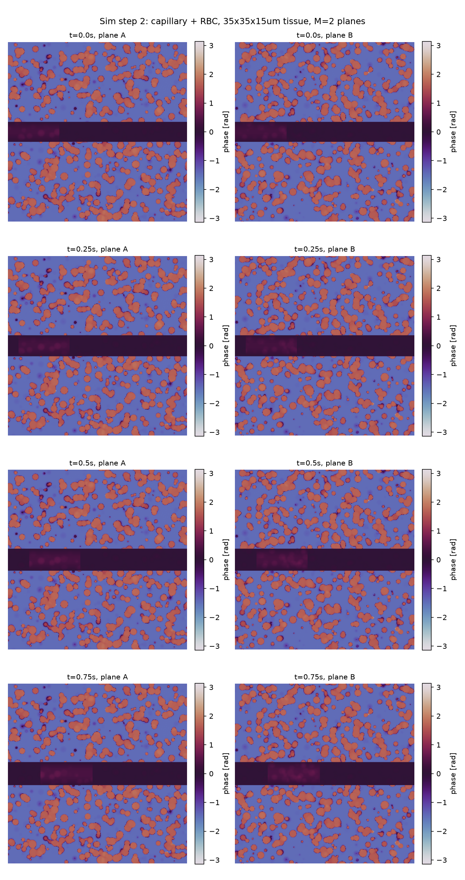

9. NOT done tonight -- deferred by your explicit instruction
step_one.py was not rerun, and the two existing tissues (2_planes_system/tissue_output_2planes_20x20x10.mat, tissue_output_2planes_50x50x10.mat) were not regenerated.
Both were generated before the averaging bug fix, so -- like every plane generated so far -- they're effectively thin ~0.1-0.2um slices rather than proper plane-thickness averages. They still work (nothing crashes, the physics just isn't quite what step_one.py's derivation assumed), but for correct results, both driver scripts (run_tissue_3d_generator_2planes.m, run_tissue_3d_generator_2planes_50x50x10.m) need to be rerun against the fixed generator, and step_one.py rerun against the regenerated .mat files. Both driver scripts still work unmodified against the fixed function (MATLAB allows requesting fewer outputs than a function declares), so this is a rerun, not a rewrite. New random sphere realizations are expected (no seed was ever fixed), matching how this project has handled regeneration before.

